Image Enhancement using Merged Algorithms

Loura Shiny M, 19BCE1524, Theninpan.R, 19BCE1817

Vellore Institute of Technology, Chennai.

*Abstract*:- **Image processing is becoming an up-and-coming research domain. There are multiple works done on image enhancement. Image enhancement is done to improve the display of the image or for image analysis by adjusting it through removing noises or sharpening or brightening the image. Quality of an image is lost overtime due to some external factors such as wear and tear, environmental factors, atmospheric factors, etc. And this causes image degradation. There are many applications these days so as to restore/ enhance image quality. Here, a combination of different high pass and low pass filters will be used to enhance the degraded images. This is will give rise to new Merged Algorithms.**

*Keywords -* ***Image Enhancement, Motion Blur, Inverse Filter, Weiner Filter, Median Filter***

1. **INTRODUCTION**

Image Processing is a vast branch which develops algorithms to solve a variety of problems such as image restoration, image enhancement, image reconstruction, image preprocessing, image analysis, etc [6]. Under the various areas of study in Image Processing, image enhancement is pivotal as it helps in enhancing degraded, damaged images. The quality is reduced to many factors such as wear and tear, bad storage, environmental conditions, humidity, atmospheric conditions, insects, nematodes, tint, etc [9].

Image degradation occurs due to many reasons but mainly due to presence of noise and blurring. Nosie is caused due to the presence of any undesirable information in the image, it infects the image and reduces its quality. Blurring is caused because of the relative motion between the target and the device used to take the picture [1]. Image enhancement techniques will help reduce or cancel the noise and blur from the degraded image [8].

In this research work we’ll combine different high pass and low pass filters to enhance degraded images. High pass filters are used for image sharpening whereas low pass filters are used for image smoothing. High pass filters attenuated low frequency while preserving high frequency and vice versa happens in low pass filters [10].

Here Inverse Filter and Wiener Filter will be used as the high pass filters.

**Inverse Filter:**

Considering the motion-blurred image is as follows,

$$g\left(x\right)=f\left(x\right)*h(x)$$

Where, **f** is the original image convolved,

**h** is the blurring kernel convolved, and

**g** is the blurred image.

In Inverse filter, we divide the blurring kernel from the image

$$f\left(x\right)=\frac{g\left(x\right)}{h(x)}$$

Then apply Inverse Fast Fourier Transformation (IFFT) to *f(x)* to get the degraded image restored to an extent.

**Wiener Filter:**

To apply wiener filter to the degraded image $g(x)$, first Discrete Fourier Transform (DFT) must be taken to obtain $G(x)$. The original image spectrum - $S(x)$ will be estimated by taking the product of $G(x)$ with the Wiener filter $W(x)$.

$$S(x) = W(x) * G(x)$$

The inverse DFT of $S(x)$ is used to obtain the image estimate from its spectrum.

The Wiener filter is:

$$F^{'}\left(x\right)=\frac{H^{*}\left(x\right)}{|{H\left(x\right)|}^{2}+k}G(x)$$

Where, $F'(x)$ is the image enhanced using Wiener Filter, $H(x)$ is Fourier Transform image, and $H^{*}\left(x\right)$ is the conjugate of, $k$ is the reciprocal of signal to noise ratio.

Mean, Median and Mode filters using clockwise route method [1] will be used as the low pass filters.

**Mean Filter:**

The pixel value is replaced by the average of the pixel surrounding it in the filter.

**Median Filter:**

The pixel value is replaced by the middle pixel values when all the pixel values surrounding it in the filter is arranged in ascending order.

**Mode Filter:**

The pixel value is replaced by the pixel value that has the most frequency from the surrounding in the filter.

Here the low pass filters – mean, median and mode will also be applied by a method called Clockwise Route Method [1] proposed by Abd Ali, Sahlah in the year 2019 in the paper “Image Enhancement Techniques for Images at Blur Motion and Different Noises”. This method was opted as it helps preserve edges.

**Clockwise Route filter:**

**Step1:** Follow the route along the first-row element and then find that strip’s mean/ median/ mode.

**Step 2:** Repeat step 1 for the last column and then last row strips.

**Step 3:** Find the mean/ median/ mode of those values found in step 1 and step 2.

**Step 4:** Now, follow the route along the last half of the first column and do step 1 for this strip.

**Step 5:** Next, take the first half of the middle row and repeat step 1 for this strip.

**Step 6:** Lastly take the values found in step 4, 5 and 6 and then find the mean/ median/ mode.

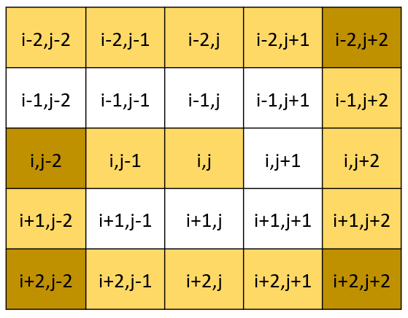

***Figure 1:*** 5X5 Matrix representation of Clockwise Route Method

Standard performance values such as Peak signal to noise ratio (PSNR), Entropy, Root Mean Square Error (RMSE), Mean Absolute Error (MAE) and Mean Square Error (MSE) will be used to assess the enhancement.

This research work was done using MATLAB R2021a. "Standard" test images (a set of images found frequently in the literature: Lena, peppers, cameraman, lake, etc., all in uncompressed tif format and of the same 512 x 512 size) were used input here.

1. **OBJECTIVES OF THE WORK**

To enhance images that are degraded due to motion blur and different noises (speckle, gaussian, salt and pepper) using a combination of high pass and low pass filters.

1. Applying Inverse Filter with Clockwise Route Method Mean/ Median/ Mode filter.
2. Applying Wiener Filter with Clockwise Route Method Mean/ Median/ Mode filter.

Tabulate the obtained results and compare the results.

1. **PROPOSED WORK:**
   1. **ARCHITECTURAL DIAGRAM:**

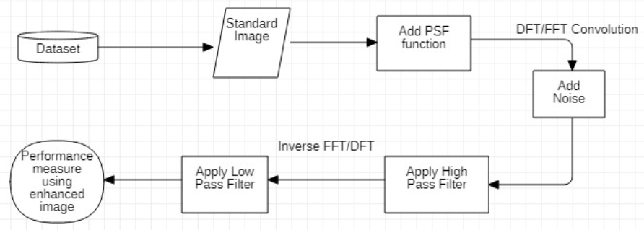

***Figure 2:*** Architectural Diagram of the proposed work

**3.2. ALGORITHM:**

**Step 1:**

Readinput image.

**Step 2:**

Apply PSF (PSF = fspecial('Motion', Len, Theta)) on original image. Then, using Fast Fourier Transform convolve the PSF image to create a motion blurred image.

**Step 3:**

Add Speckle noise (J = imnoise(I,'speckle')) to the motion blurred image using Matlab function. Now, we get the degraded image.

**Step 4:**

Now, apply the high pass filter – Inverse/ Wiener separately to the degraded image.

**Step 5:**

Then apply the high pass filters – mean/ median/ mode to the low pass filter applied image.

**Step 6:**

Now, calculate the entropy, RMSE, MAE, PSNR and MSE values (performance measures) for all the output images and tabulate the results.

**Step 7:**

Now, repeat the same for Gaussian noise and Salt and Paper noise.

1. **RESULTS**

**4.1 SPECKLE NOISE:**

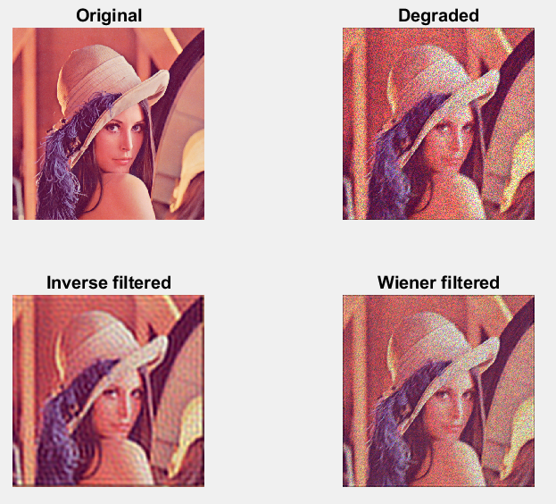

***Figure 3:*** Original and Degraded image along with Inverse and Wiener Filter applied to the Degraded image.

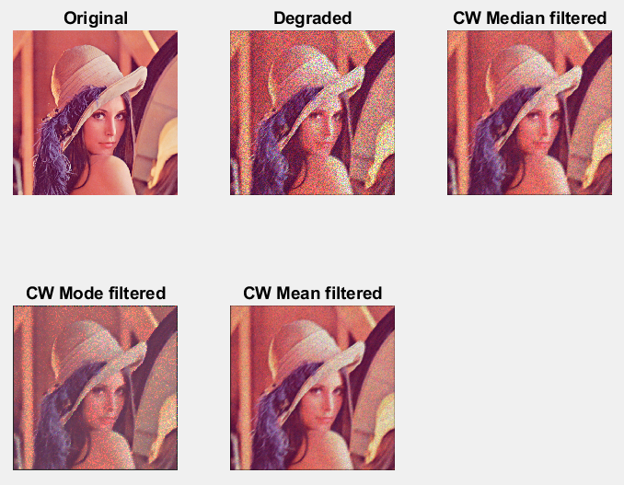

***Figure 4:*** Original and Degraded image along with Clockwise Route Mean, Median and Mode filter applied to the degraded image

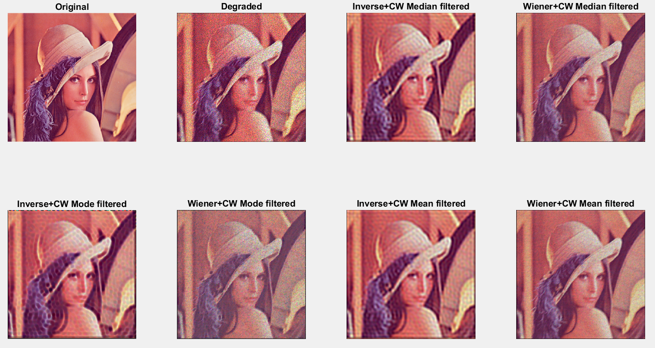

***Figure 5:*** Original and Degraded image along with proposed merged algorithms applied to the degraded image –

Inverse + Median, Wiener + Median, Inverse + Mode, Wiener + Mode, Inverse + Mean, Wiener + Mean

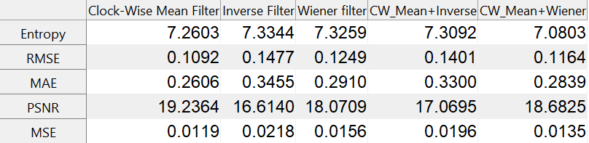

***Figure 6:*** Standard performance value comparison table for Mean Filter

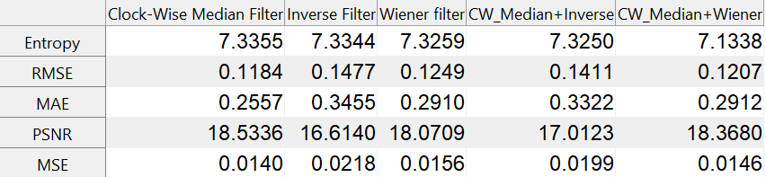

***Figure 7:*** Standard performance value comparison table for Median Filter

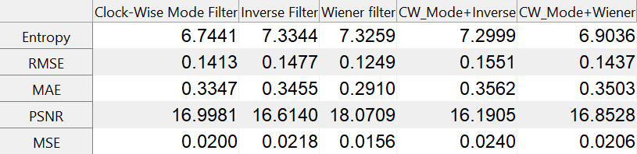

***Figure 8:*** Standard performance value comparison table for Mode Filter

**4.2 SALT AND PEPPER NOISE:**

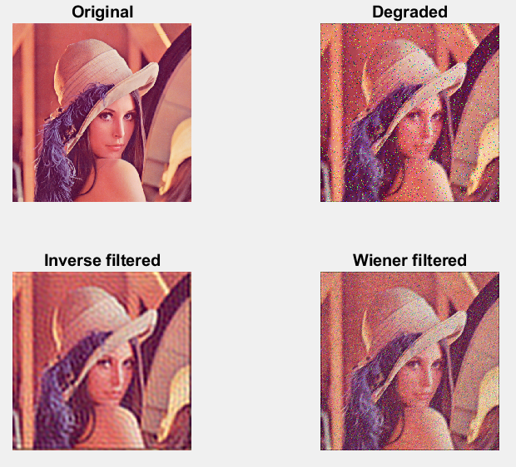

***Figure 9:*** Original and Degraded image along with Inverse and Wiener Filter applied to the Degraded image.

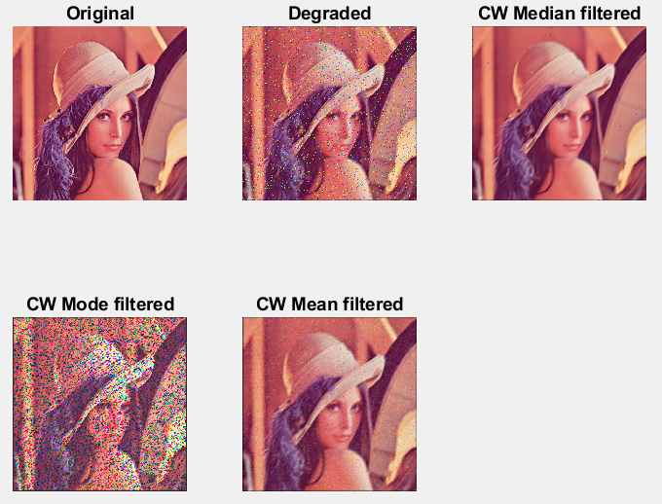

***Figure 10:*** Original and Degraded image along with Clockwise route Mean, Median and Mode filter applied to the degraded image

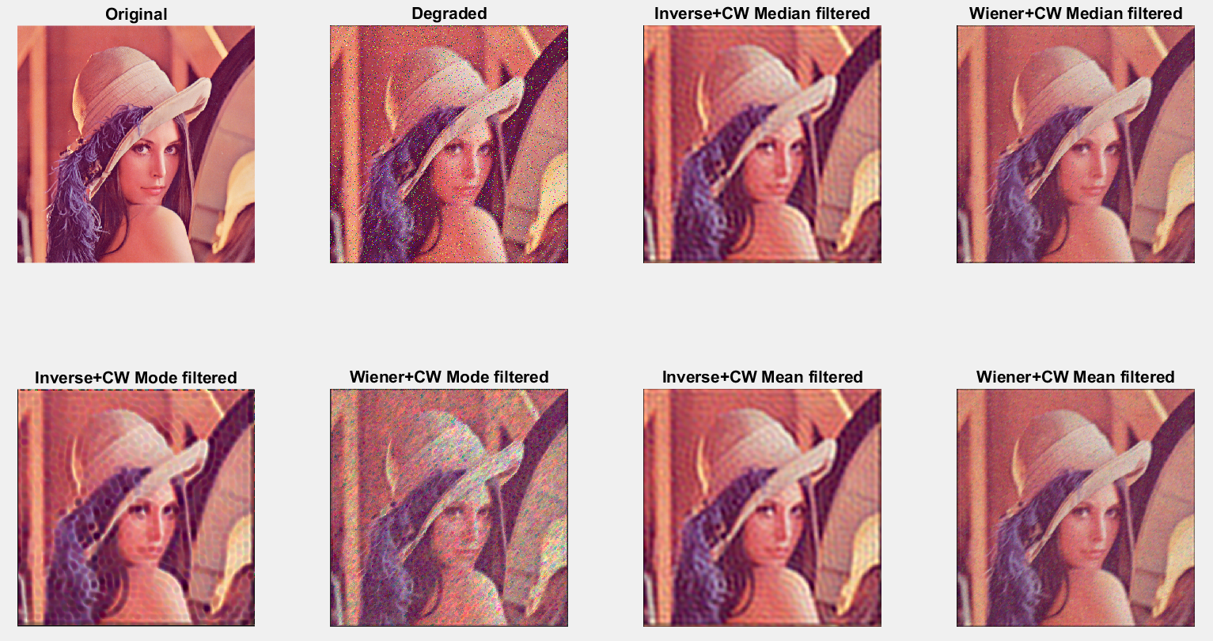

***Figure 11:*** Original and Degraded image along with proposed merged algorithms applied to the degraded image –

Inverse + Median, Wiener + Median, Inverse + Mode, Wiener + Mode, Inverse + Mean, Wiener + Mean

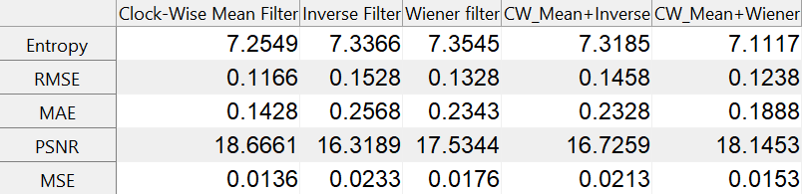

***Figure 12:*** Standard performance value comparison table for Mean Filter

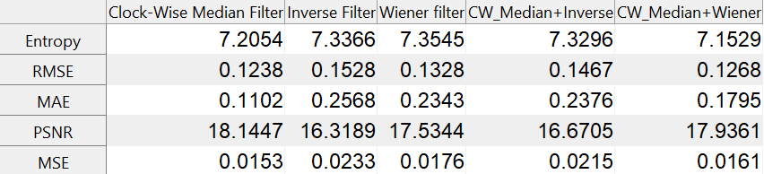

***Figure 13:*** Standard performance value comparison table for Median Filter

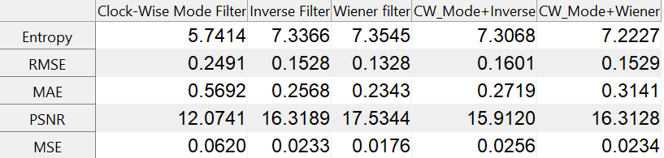

***Figure 14:*** Standard performance value comparison table for Mode Filter

**4.3 GAUSSIAN NOISE:**

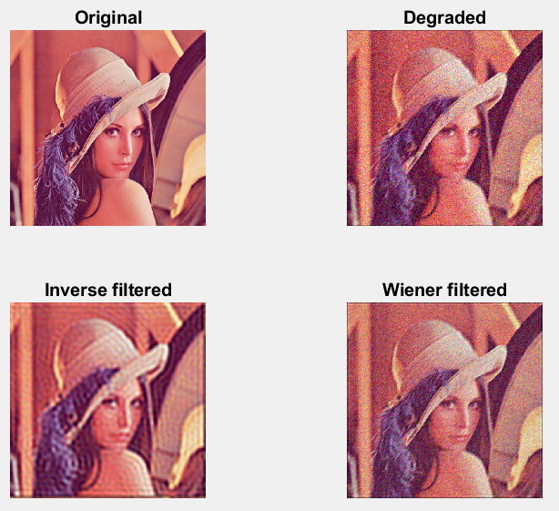

***Figure 15:*** Original and Degraded image along with Inverse and Wiener Filter applied to the Degraded image.

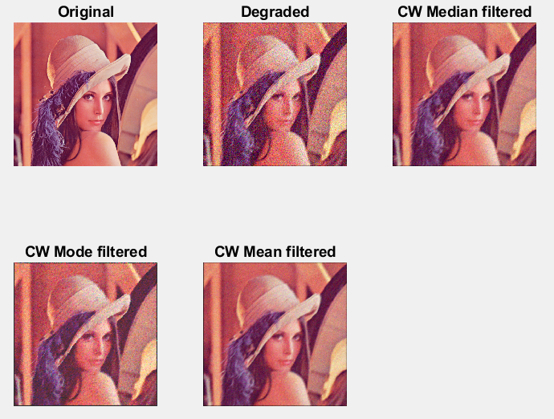

***Figure 16:*** Original and Degraded image along with Clockwise route Mean, Median and Mode filter applied to the degraded image

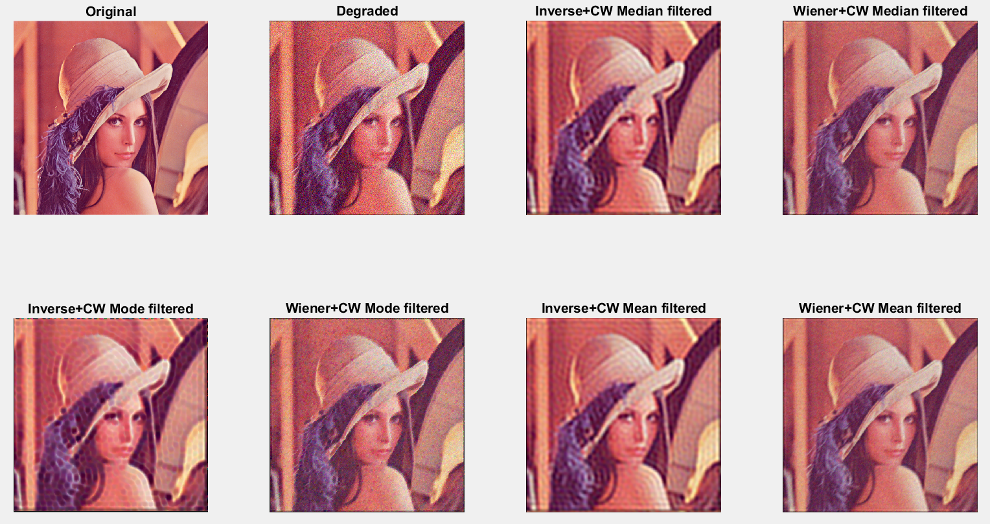

***Figure 17:*** Original and Degraded image along with proposed merged algorithms applied to the degraded image –

Inverse + Median, Wiener + Median, Inverse + Mode, Wiener + Mode, Inverse + Mean, Wiener + Mean

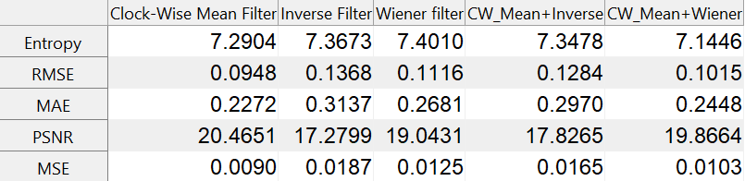

***Figure 18:*** Standard performance value comparison table for Mean Filter

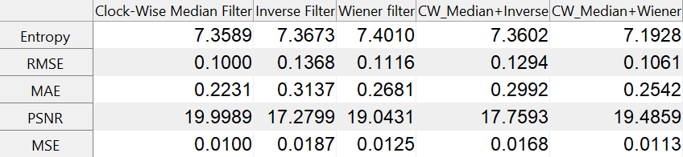

***Figure 19:*** Standard performance value comparison table for Median Filter

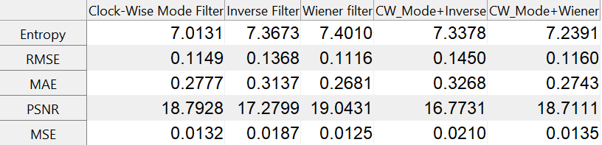

***Figure 20:*** Standard performance value comparison table for Mode Filter

For speckle noise, Clockwise route Mean Filter has the lowest RMSE (0.1092) and MSE (0.0119) value, Clockwise route Median has the lowest MAE (0.2557) value and Clockwise route Mean Filter has the highest PSNR (19.2364) value. Thus, we can say that the Clockwise route Mean Filter works the best when compared with the other here with the image is degraded with motion blur and speckle noise. From the merged algorithms, the combination of Wiener Filter and Clockwise Route Mean Filter (PSNR: 18.6825) works the best.

For salt and pepper noise, Clockwise route Mean Filter has the lowest RMSE (0.1166) and MSE (0.0136) value, Clockwise route Median has the lowest MAE (0.1102) value and Clockwise route Mean Filter has the highest PSNR (18.6661) value. Hence, we can conclude that Clockwise route Mean Filter works better when degraded with motion blur and salt and pepper noise. From the merged algorithms, the combination of Wiener Filter and Clockwise Route Mean Filter (PSNR: 18.1453) works well.

For gaussian noise, Clockwise route Mean Filter has the lowest RMSE (0.0948) and MSE (0.0090) value, Clockwise route Median has the lowest MAE (0.2231) value and Clockwise route Mean Filter has the highest PSNR (20.4651) value. Thus, we can say that Clockwise route Mean Filter works better when degraded with motion blur and gaussian noise. From the merged algorithms, the combination of Wiener Filter and Clockwise Route Mean Filter (PSNR: 19.8664) works the best.

Not using high pass filter results in images visually having blur and not using low pass filters ends with images that have noise.

**LIMITATIONS AND FUTURE WORKS:**

The time taken to run these algorithms was a lot. Research can be done to optimize the code or the filters to reduce the run-time. Similarly other combinations of high pass such as Butterworth High Pass Filter, Gaussian High Pass Filter and low pass filters like Max Filter, Min Filter, Mid-point Filter.

1. **CONCLUSIONS AND FUTUREWORK**

From the results obtained we can conclude that to remove motion blur, Wiener Filter works better than Inverse Filter and we can see that from the performance matrix obtained from all three noise types.

To remove noise, Clockwise Route Mean work the best on all the mentioned noises – speckle, salt and pepper, and gaussian. From the merged algorithms, the combination of Wiener Filter and Clockwise Route Mean Filter enhances the image degraded from motion blur and noise (speckle, salt and pepper, and gaussian) the best.

1. **REFERENCE:**
2. Abd Ali, Sahlah. (2019). Image Enhancement Techniques for Images at Blur Motion and Different Noises. AL-Rafidain Journal of Computer Sciences and Mathematics. 13. 48-60. 10.33899/csmj.2020.163502.
3. E. R. Davies, "Design of robust types of mode filter for signal and image processing applications," IEE Colloquium on Non-Linear Filters, 1994, pp. 2/1-2/6.
4. S. Khetkeeree and S. Liangrocapart, "Image Restoration Using Optimized Weiner Filtering Based on Modified Tikhonov Regularization," 2019 IEEE 4th International Conference on
5. Signal and Image Processing (ICSIP), 2019, pp. 1015-1020, doi: 10.1109/SIPROCESS.2019.8868907.
6. HYPERMEDIA IMAGE PROCESSING REFERENCE, Copyright © 2000 Robert Fisher, Simon Perkins, Ashley Walker and Erik Wolfart.
7. R. C. Gonzalez and R. Woods, "Digital Image Processing", Pearson Publishing Company,2018
8. S. K. Satpathy, S. Panda, K. K. Nagwanshi and C. Ardil, "Image Restoration in Non-Linear Filtering Domain using MDB approach", World Academy of Science, Engineering and Technology International Journal of Computer and Information Engineering Vol:7, No:2, 2013.
9. Deepa Puri , Prof. Santosh Kumar Mishra, "Analysis of Image Restoration Techniques at Different Noises", Computer Science and Engineering, VNSIT Bhopal, International Journal of Computer Science and Information Technologies (IJCSIT), Vol. 8 (3) , 2017, 439-442.
10. Deborah, H., & Arymurthy, A. M. (2010, December). Image enhancement and image restoration for old document image using genetic algorithm. In 2010 Second International Conference on Advances in Computing, Control, and Telecommunication Technologies (pp. 108-112). IEEE.
11. Makandar, Aziz, and Bhagirathi Halalli. "Image enhancement techniques using highpass and lowpass filters." International Journal of Computer Applications 109.14 (2015): 12-15.